Project Name: Hershey’s Oct. 2021
Elevit D2C Precision Marketing Brief for r4 Technologies Inc. Prepared by BCHJ Marketing, Hiroe Kurihara
- Objective:
This brief aims to seek solutions to - 1, grow Elevit lifetime value (LTV) through expanding usage into pregnancy, 2, cross-sell through precision marketing in adjacent segment, eg. Menevit in planning, DHA in pregnancy, etc.

- Our issue:
Bayer Consumer Health Japan (BCHJ) runs a direct-to-consumer e-commerce business (D2C) which sells Elevit products directly to consumers, bypassing any third-party retailers or wholesalers. In D2C, consumer data is a key. BCHJ currently owns 250K women’s personal data that has been accumulated since 2017. However, their life stage data has not been updated since they registered, so BCHJ cannot do a precise 1on1 communication to be relevant with their life stage: planning a baby (pre-conception), being pregnant in the first, second, third trimester, or postnatal. Moreover, it requires human resource and time to marge several different data sources to find insights. As consequence, 1, some consumers who purchased in the pre-conception stage cancelled the subscription order of Elevit prenatal supplement when they get pregnant or be in the 2nd trimester, ie. the 16th weeks of pregnancy. 2, we can’t tailor communication message for the cross-sell products offered during pregnancy stage, as we cannot know which stage they are in. With these two issues, Elevit’s LTV and the cross-sell hasn’t reached its full potential as the DTC model aims for.
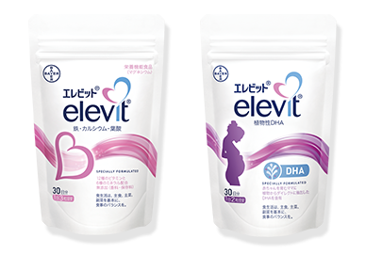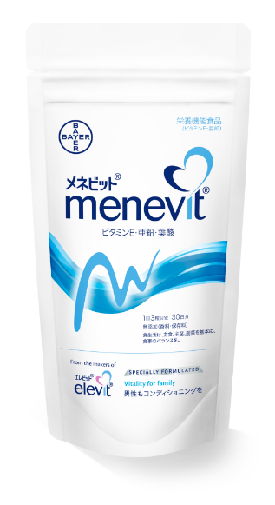
Elevit Prenatal Supplement for women in pre-conception and pregnancy
Elevit DHA supplement for pregnant women
Menevit for male partner of women in pre-conception
*All SKUs one moth dosage in a pack

- Expected Outcome:
Current consumer perception and behavior:
“Finally, I get pregnant! Since I was very desperate to have a baby, I tried many things such as taking supplements. Now I get pregnant, so do not need it anymore. I will cancel the subscription of Elevit.”
Future consumer perception and behavior:
“Oh, Elevit mail magazine (eDM) tells me, even after the 16th weeks, pregnant women should take Elevit because Japanese pregnant women usually lack sufficient nutrition. I want to do my best for my baby, so I should continue it. It also says, a DHA supplement enriches pregnant women’s diet. I want to add it. Thank Elevit helping my diet and knowledge for my healthy baby’s development!”

Elevit brand “First 1,000 Days” concept that we want to enhance and educate in Japan
Our vision is to have every child have the best start in life. Recent studies reveal that a child has adequate nutrition and care in the first 1,000 days, this child will be healthier and thrive. This healthy development journey starts from conception. Elevit brand offers appropriate choices of nutrition for each stage. It has the ambition to set the full product lineup from pre-conception to children’s two years birthday until 2025. Japan’s next new launch product is a supplement for breastfeeding women in 2023.
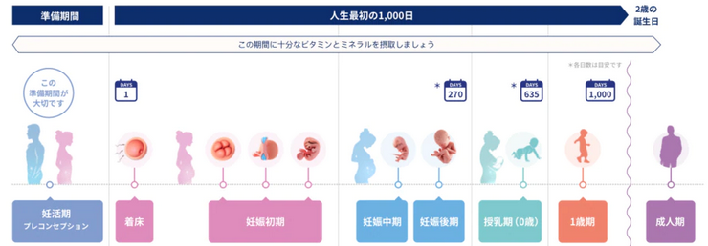
- Project Goal/Ambition
  - Among those who started Elevit PMVS subscription order from their pre-conception stage, the usage retention is extended until they give birth to their baby.
    - Stop the cancelation of the subscription order (SnS) of PMVS in the pregnancy stage.
    - Benchmark: 9 units usage in pregnancy.
    - KPI: improve units selling split between planning and pregnancy from 7:3 to 5:5. (Milestone to be aligned in debriefing stage).
  - Among pregnant women in Elevit CRM data base,
    - Improve the accurate labeling of pregnancy
    - Improve cross-sell ratio of the DHA product with Elevit prenatal supplement becomes 30% .

- Expected Deliverables
  - Your service proposal to achieve the project goal/ambition listed above
  - Project milestone and timeline
  - Assumption of business impact and benefit with numerical rationale.
  - A “Success Metrix” based quotation

Appendix - More Context and Background
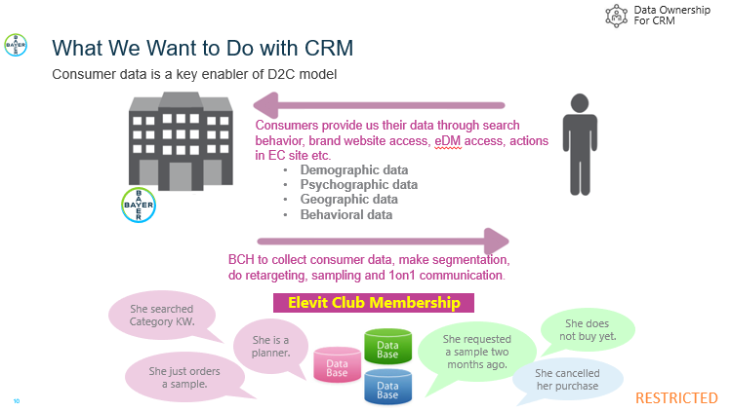
- Our Pain Points in Life Stage Data Flag
- When the women register their information in our CRM platform getting a free sample, they are asked their pregnancy status: planning a baby or already being pregnant to enable us to send relevant communication. However, this life stage flag has not been updated once they register, therefore its status declaration becomes old after the registration. Some women are still planning after a few years since the registration and if they are under infertility treatment with emotional pressure, the communication about pregnancy should be bothersome for them. At the same time, BCHJ does not want to ask the women to update their life status in the system, because it leads their action to visit “my page” to change the status and think “Should I cancel the subscription order?” “Should I withdraw from Elevit email newsletter?”. Therefore, we are looking for some alternative ways to predict their latest life stage without arousing their cancelation of their membership or subscription order.

- Our Pain Points in CRM
- Data integration and segmentation to do personalized marketing leveraging consumer data.
  - Lack of agility to link several consumer-data-source saved in the Bayer or TCI data warehouse. Our EC team uses an interface tool to integrate data for their situational needs. During the data integration between Bayer and TCI, bugs are often occurred, and the team takes time to identify and fix bugs. Therefore, the agility of the marketing action tends to be losing and the granularity of the personalized marketing depends on the available human resource and efforts to manage the data integration.
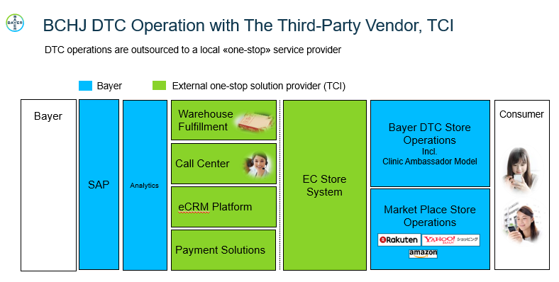

  - Limitation to connect the variety of data beyond the data saved in the Bayer and TCI data warehouse. The CSJ (Consumer Shopper Journey) usually starts when consumers have interests in the category or planning a baby. The CSJ is not a beeline. Consumers usually go back and forth same or different touchpoints. In fact, they must visit the brand web site or purchase points such as Shop Site or MP frequently while they cannot decide to buy. Their behaviors in our website can be observed by Google Analytics, and paid media and social media activities are analyzed by other tools. These tools are separate with the Bayer and TCI data warehouse, so the entire CSJ process is not visible without the holistically integrated view from trigger to purchase points. If we can know more precise CSJ by the variety of the consumer typologies, our marketing communication and media plan can be more personalized and efficient.

(Our image/guess of entire CSJ and touchpoints by consumer persona)

- Marketing automation (MA) to execute personalized marketing actions for respective consumer segments.
Our CRM manager designs a consumer segmentation “list” and communication “scenario” for MA actions. Our MA tool is Customer Rings provided by a Japanese company. Customer Rings cannot link with the brand website.
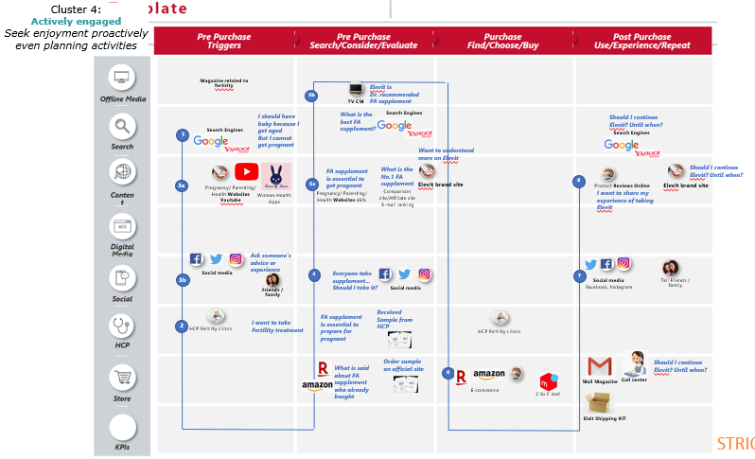
Note: All of the pain points above should need deep dive by doing interviews with the end users of each tool who are BCHJ EC team employees. It should be a key understanding the data operation, the variety of data format and data policy to deliver a realistic proposal of your service. Hiroe can arrange interview sessions between r4 Technologies and the end users per your request. Ideally it should be done in Japanese as our members can provide accurate and informative inputs in their mother tongue.

